Marketing and Customer Analytics to Improve Housing Access and Outreach for Individuals Experiencing Homelessness
Group 1: Mercy Harris, Zariana Mobley and Braeden Baker
Fayetteville State University
School of Business
Advanced Analytics- BIDA 670
Professor Majed Al- Ghandour
March 30,2026

Phase II:
General Overview of the Contents
​This project explores how marketing strategies and customer analytics can enhance housing outreach and access to housing resources for individuals experiencing homelessness. ​The analysis will focus on evaluating outreach effectiveness, identifying engagement patterns, and understanding barriers that influence participation in housing programs. ​The project's goal is to develop data-driven recommendations to strengthen outreach strategies, increase program participation, and improve long-term housing stability.
Motivation
​Homelessness remains a significant societal and economic challenge in the United States, with many individuals facing obstacles to stable housing, employment, and support services. ​People experiencing homelessness often have limited access to housing resources and may find it difficult to navigate complex housing assistance systems. ​Housing assistance organizations and nonprofit programs play a crucial role in addressing these issues through outreach, referrals, and supporting individuals through the housing placement process. ​However, many current outreach strategies lack consistent or data-driven evaluation methods, making it hard to determine their effectiveness in increasing awareness, program participation, or successful housing placements. ​This project is motivated by the need for innovative and data-driven approaches to connect individuals with stable housing solutions, ultimately accelerating their journey to housing stability and reducing the duration of homelessness.

​The primary goal of this project is to create a robust framework for identifying, engaging, and supporting individuals experiencing homelessness through personalized and effective interventions. This involves several key objectives:
Customer Segmentation and Needs Assessment: ​This includes analyzing existing demographic, health, and housing history data to identify distinct segments within the homeless population. ​It also involves conducting qualitative research, such as interviews and focus groups, to understand specific housing barriers, communication preferences, and perceived needs of each segment.
Outreach Channel Optimization: ​This objective focuses on evaluating the effectiveness of current outreach methods, such as street outreach, shelter programs, and community events. ​It also involves developing and testing new communication strategies, including digital outreach, partnerships with community organizations, and peer-to-peer engagement.
Personalized Resource Matching and Navigation: ​This aims to create a system that matches individuals with appropriate housing programs and support services based on their identified needs and eligibility. ​It also includes developing tools and training for outreach workers to provide personalized guidance throughout the housing application and transition process.
Impact Measurement and Continuous Improvement: ​This objective involves establishing key performance indicators (KPIs) to track the effectiveness of outreach and housing access programs, such as housing placement rates and reductions in repeat homelessness. ​It also includes implementing a feedback loop to continuously refine strategies based on data analysis and program outcomes.

Problem Definition
​Many outreach efforts lack strong evaluation, making it difficult for organizations to determine which methods increase participation or support successful placement. ​The escalating crisis of homelessness demands innovative and data-driven approaches to connect individuals with stable housing solutions. ​Without strong evaluation methods, organizations may miss opportunities to improve outreach and better connect individuals with housing resources.
Literature Review
​Research into interventions for individuals experiencing homelessness has explored various approaches, but there are still gaps in understanding their effectiveness and how to integrate them into broader community support. ​For instance, while community integration (CI) is a key outcome for programs aimed at improving the lives of homeless individuals, there is inconsistency in how effectively existing interventions target CI. ​Studies evaluating Housing First (HF) and housing support interventions have shown mixed or a lack of effectiveness for promoting CI, while psychosocial interventions, especially those with peer support, appear more promising. ​Furthermore, systems-level interventions like HF and permanent supportive housing alone may not be sufficient to promote CI among homeless and formerly homeless individuals, highlighting a need for further research into more effective interventions.
​Modern statistical and machine learning methods are increasingly being used to model individual treatment effects, which could inform the allocation of interventions based on individual characteristics. ​In social services, where resources are often limited, these predictions could lead to substantial benefits, such as reducing repeated episodes of homelessness through optimal allocation to different types of facilities. ​However, such changes in allocation mechanisms may involve tradeoffs, as some households might experience a higher probability of re-entry into homelessness, raising efficiency, equity, and fairness concerns that require careful policy consideration.
​Government strategies to combat homelessness have evolved significantly, and there is an ongoing need to catalog policy responses and evaluate the effectiveness of these strategies. ​Research often focuses on randomized controlled trials and quasi-experimental designs to assess interventions, but major gaps remain in the existing literature that future research needs to address. ​A systematic review is proposed to map the evidence and identify gaps in studies evaluating the effectiveness of interventions aimed at improving the welfare of those affected by or at risk of homelessness in high-income countries. ​This comprehensive search and systematic screening will present available studies in an interactive online map and a supporting report to inform evidence-based policies and programs.
​Marketing strategies for homeless shelters and housing insecurity involve creating emotionally engaging content, leveraging social media platforms, and building a game plan around organizational goals, staff capacity, and budget. ​Nonprofit marketing plans can empower organizations to drive meaningful action to support homeless and at-risk populations. ​Outreach workers who engage directly with individuals in the community frequently mentioned successful strategy. ​Social marketing approaches can help reduce homelessness by informing and inspiring action. ​Digital marketing research and campaigns can also create public agreement that housing is a fundamental right. ​Effective social media marketing for homeless shelters focuses on clear, human, and respectful storytelling, using branded graphics for awareness and campaigns. ​Businesses can also navigate challenges caused by homelessness by offering tailored solutions and supporting homelessness toolkits. ​Campaigns leveraging platforms like Meta Platforms (Facebook and Instagram) and Next-door can raise awareness and drive traffic to resources. ​Out-of-home (OOH) advertising, such as billboards, is also used by action groups and non-profit organizations to raise awareness and seek support for the homeless.
​Nonprofit analytics involves systematically collecting, cleaning, and analyzing program data, including both quantitative and qualitative metrics. ​This practice helps nonprofits understand their impact, optimize strategies, and make informed decisions by tracking donor behavior, program success, and operational efficiency. ​Data analytics can help validate trends, uncover root causes, and improve transparency for nonprofits. ​Customer data platforms (CDPs) enable organizations to collect, analyze, and act on constituent feedback efficiently. ​Over 70% of nonprofits now use some form of data analytics to enhance their fundraising efforts. ​Analytics tools also simplify large datasets concerning homeless populations, services, and intervention outcomes, which is crucial for policy evaluation. ​Tracking client outcomes provides valuable feedback for improving program effectiveness and real-world accomplishments.
​Data-driven approaches are essential for addressing homelessness and improving housing access. ​There isn't a single data source that fully captures the scope of homelessness and housing needs, necessitating the use of various data types. ​Quantitative data helps identify demographic and geographic patterns, resource gaps, and disparities in unsheltered homelessness. ​Communities utilize Homeless Management Information Systems (HMIS) to track individuals accessing services, building rich datasets on homeless people. ​Improved data collection allows cities to more effectively reach homeless residents and deliver essential social services and housing. ​Technology and data analytics can significantly enhance traditional approaches to reducing homelessness. ​Data-driven solutions enable communities to break the cycle of homelessness, reduce public costs, and improve community well-being. ​Data-driven methods, such as data matching from administrative records like hospitals or mental health systems, can help identify individuals experiencing homelessness. ​Identifying individual-level data and triggers to homelessness, such as eviction filings, can inform data-driven models for eviction prevention.
​Evaluating the effectiveness of homeless outreach programs involves looking at system-wide effectiveness across all homeless assistance programs or a subset of the larger system. ​Effective homeless response systems should include outreach to unsheltered individuals, coordinated entry, and targeted prevention and diversion. ​Evaluations help programs answer questions about client outcome improvement and the factors contributing to success. ​Research literature suggests various positive outcomes associated with homeless outreach programs. ​Studies have examined the effectiveness of interventions to reduce homelessness and increase residential stability. ​Homeless prevention programs, including financial assistance, have shown impacts on reducing homelessness. ​The Homeless Prevention and Rapid Re-Housing Program (HPRP) has been associated with short-term reductions in homelessness among students and their families. ​Programs like Home Safe have had lasting positive impacts by improving coordination between social services and homelessness staff. ​Evaluating the effectiveness of strategies, including budget allocation, is crucial for achieving intended outcomes in addressing homelessness.
Approach / Methodology
​ This project utilizes a mixed-methods analytical approach that combines both quantitative and qualitative techniques to evaluate housing outreach effectiveness. On the quantitative side, publicly available HUD Point-in-Time (PIT) data was used to analyze trends in homelessness over time, with a specific focus on Cumberland County. The dataset was cleaned and transformed using Power BI, where data from multiple years was consolidated into a single structured dataset. Key variables such as total homeless population, sheltered individuals, and unsheltered individuals were standardized and aggregated to support time-series analysis.

Key performance indicators (KPIs) were developed to measure current system conditions and outreach effectiveness. These KPIs include total homelessness, sheltered population, and unsheltered population, with a focus on the most recent available year to provide a snapshot of current conditions. These metrics allow for evaluation of how effectively individuals are being connected to housing resources.

In addition to quantitative analysis, qualitative data will be incorporated in Phase III through structured interviews with local organizations and individuals experiencing homelessness. Interview responses will be coded and transformed into structured variables to support segmentation analysis and identification of key barriers to housing access. This integration of qualitative and quantitative data enables a more comprehensive understanding of outreach effectiveness and supports data-driven decision-making.

Overall, this methodology emphasizes a data-driven and iterative approach, where insights from both datasets and interviews can be used to refine outreach strategies, improve resource allocation, and enhance long-term housing outcomes.
Data Collection
Data collection for this project includes both secondary and primary data sources to provide a comprehensive view of homelessness trends and outreach effectiveness.
The primary quantitative dataset used in this analysis is the U.S. Department of Housing and Urban Development (HUD) Point-in-Time (PIT) dataset, which provides annual counts of sheltered and unsheltered individuals experiencing homelessness at the Continuum of Care (CoC) level. This dataset was selected due to its reliability, consistency, and national standardization, allowing for longitudinal analysis from 2007 through 2024. The analysis specifically focuses on the Fayetteville/Cumberland County CoC to align with the project’s geographic scope.
Secondary data sources include demographic, housing, and program-level data referenced in existing literature, as well as potential integration with Homeless Management Information Systems (HMIS) data where accessible. These datasets provide context for identifying trends, resource gaps, and population segments within the homeless population.
Primary data collection will be conducted in Phase III through structured interviews with local housing organizations and individuals experiencing homelessness. These interviews will focus on identifying barriers to housing access, communication preferences, and factors influencing successful placement and retention. This qualitative data will complement the quantitative analysis and support deeper insights into outreach effectiveness.
All data used in this project is aggregated and anonymized to ensure ethical standards are maintained, with no personally identifiable information included in the analysis. Due to inconsistencies in data availability across years, certain variables such as chronic homelessness were excluded from current-year KPI analysis to maintain accuracy and data integrity.
Data Analysis and Key Findings
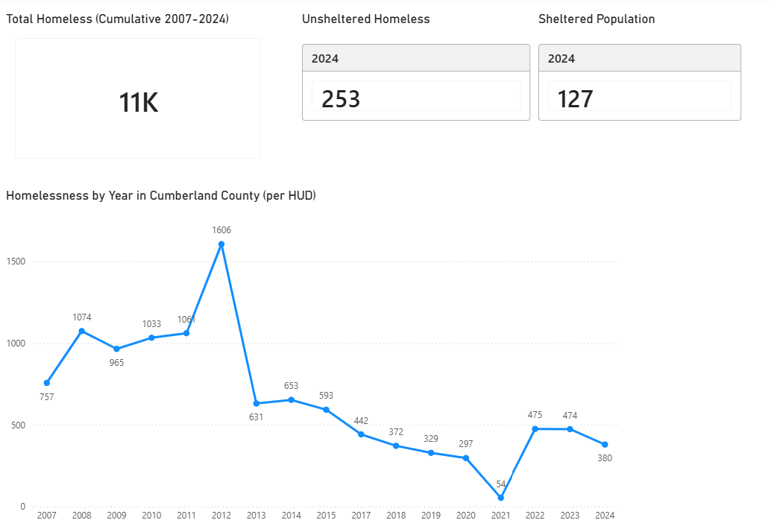
This section presents the results of the quantitative analysis conducted using HUD Point-in-Time (PIT) data for Cumberland County. Key performance indicators (KPIs) and trend analysis were developed to evaluate changes in homelessness over time and assess current system conditions.
Figure 01: Homeless Population Trend in Cumberland County (2007-2024)
The analysis shows that homelessness in Cumberland County peaked around 2012, followed by a steady decline through 2021. Although there is a slight increase in recent years, overall levels remain significantly lower than the peak period. The 2024 snapshot indicates that a notable portion of the population remains unsheltered, suggesting potential gaps in outreach effectiveness and access to housing resources. These findings highlight the importance of targeted interventions and improved outreach strategies.

References
Case Studies of Nonprofit Organizations Effectively Using ... (2025). https://socialtargeter.com/blogs/case-studies-of-nonprofit-organizations-effectively-using-data-analytics-to-drive-donations
Changing Perceptions on Homelessness Through ... (n.d.). Retrieved https://mediacause.com/our-work/case-study/changing-perceptions-mobilization-campaign/
Effective Messaging and the Solution to End Homelessness. (n.d.). Retrieved https://gomixte.com/blog/effective-messaging-solution-to-end-homelessness/
Evans, W., Phillips, D., & Ruffini, K. J. (2019). Reducing and Preventing Homelessness: A Review of the Evidence and Charting a Research Agenda. Randomized Social Experiments eJournal. https://www.nber.org/system/files/working_papers/w26232/w26232.pdf
Homelessness. (2025). https://isocialmarketing.org/homelessness/
Homelessness Toolkit to Support Local Businesses. (2025). https://fwhcc.org/homelessnesstoolkit/
Housing-Focused Street Outreach: Starting with Data to Inform Decision- ... (n.d.). Retrieved https://endhomelessness.org/webinars/housing-focused-street-outreach-starting-with-data-to-inform-decision-making/
How Can Social Marketing Help Reduce Homelessness in ... (2023). https://patimes.org/how-can-social-marketing-help-reduce-homelessness-in-the-united-states/
How to Leverage Data Analytics to Drive Non-Profit Growth. (2025). https://www.bradymartz.com/how-to-leverage-data-analytics-to-drive-non-profit-growth/
Innovative Marketing Strategies for Homeless Shelters. (2024). https://desygner.com/blog/industry/how-to-market-homeless-shelters-business
Kube, A., Das, S., & Fowler, P. J. (2019). Allocating Interventions Based on Predicted Outcomes: A Case Study on Homelessness Services. Proceedings of the AAAI Conference on Artificial Intelligence, 33(01), 622-629. https://doi.org/10.1609/aaai.v33i01.3301622
Marketing for Homeless Shelters and Housing Insecurity ... (n.d.). Retrieved https://nonprofit-nerd.com/marketing-homeless-shelters
Marshall CA, Boland L, Westover LA, Marcellus B, Weil S, Wickett S. Effectiveness of interventions targeting community integration among individuals with lived experiences of homelessness: A systematic review. Health Soc Care Community. 2020;28:1843–1862. https://doi.org/10.1111/hsc.13030
Navigating Homelessness and Housing Needs Data: Tailoring and ... (n.d.). Retrieved https://www.usich.gov/sites/default/files/document/Navigating-Homelessness-Housing-Needs-Data-2020-update.pdf
Nonprofit Analytics: Data Analysis Tools, Software & ... (2026). https://www.sopact.com/use-case/nonprofit-analytics
Social Media Marketing for Homeless Shelters - Waleed. (n.d.). Retrieved https://mwaleed.org/homeless-shelter-social-media-marketing/
Understanding the Role of Data Analytics in Homelessness Policy ... (2024). https://www.bitfocus.com/blog/role-of-data-in-homeless-policy-evaluation
Using OOH to Help the Homeless. (2019). https://oaaa.org/blog-posts/using-ooh-to-help-the-homeless/
White, H., Saran, A., Fowler, B., Portes, A., Fitzpatrick, S., & Teixeira, L. (2019). PROTOCOL: Studies of the effectiveness of interventions to improve the welfare of those affected by, and at risk of, homelessness in high‐income countries: An evidence and gap map. Campbell Systematic Reviews. https://journals.sagepub.com/doi/full/10.1002/cl2.1069
Why Data Analytics Is Within Reach For Nonprofits. (2026). https://www.mjcpa.com/why-data-analytics-is-within-reach-for-nonprofits/

